10.56: a) From the right-hand rule, the direction of the torque is 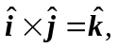 the direction.

b), c)
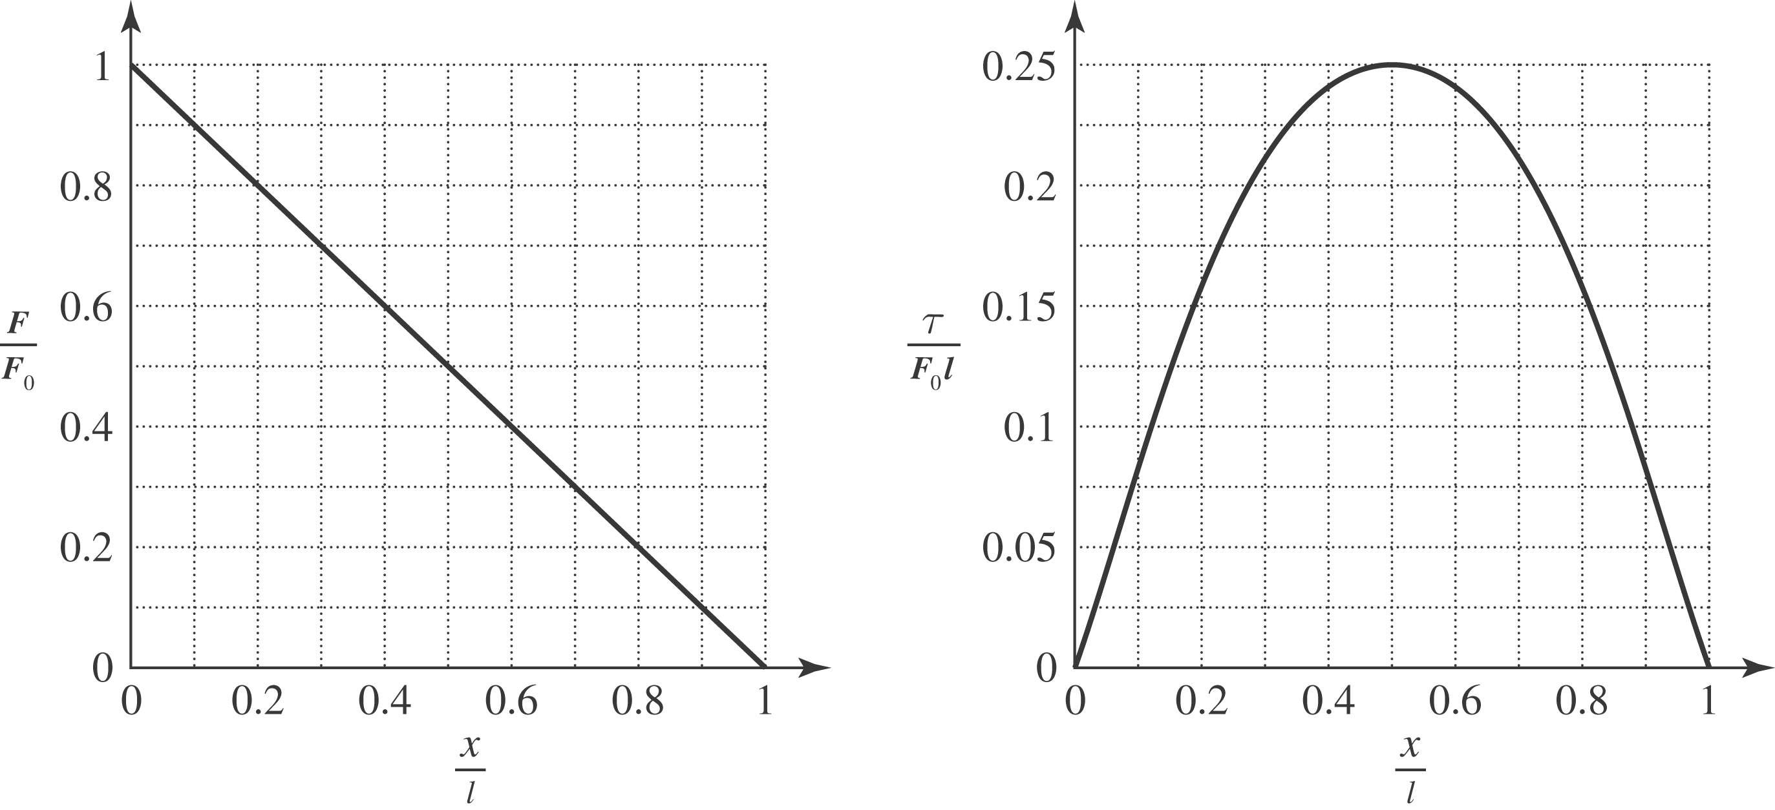
d) The magnitude of the torque is 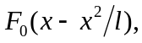 which has it maximum at 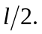 The torque at